Algebra 1 Name: _____________________________
3.1.1 Day 2 HW

Simplify each expression as much as possible leaving no negative exponents or decimals.
1. $\frac{3r^{5}}{6r}$ 2. $\frac{w^{3}}{w^{4}}$ 3. $\frac{3d^{-4}}{8d^{5}}$ 4. $\frac{6k^{6}c^{2}}{3k^{3}c^{4}}$

5. $\frac{9y^{6}}{8y^{3}d^{5}}$ 6. $\frac{cn}{7c^{5}n^{4}}$ 7. $\frac{9y^{-5}r^{-4}}{7yr^{-6}}$ 8. $\frac{3nh^{-2}}{2n^{-2}h^{3}}$

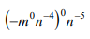
9. 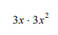 10. 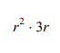 11. 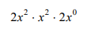 12.

13. 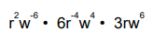 15. 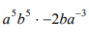 16. 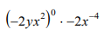

17. $\frac{4}{x^{-3}}$ 18. $6^{-2}$ 19. ${(-2)}^{-4}$ 20. $7x^{-5}$

21. Find the equation of the line with points through (4, -6) and (-16, -11). Show all your work!

22. Simplify the radicals using the perfect square numbers (1, 4, 9, 16, 25, 36, 49, 64, 81, 100…). All are possible. Show your work!

a. $\sqrt{60}$ b. $\sqrt{80}$ c. $\sqrt{144}$ d. $\sqrt{252}$

23. Determine if the graph below is a function, then identify the domain and range.
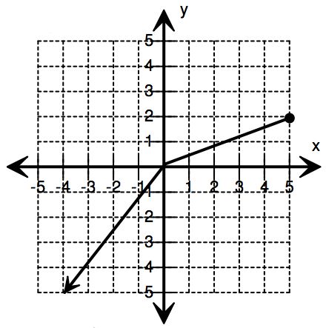
Function: ____________
Domain: ___________________
Range: ____________________

