Algebra 1 Chapter 6: Graphing Calculator Instructions

INSERTING POINTS INTO A LIST
1. Press the STAT key. Your screen should look like this. | 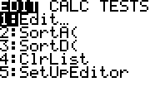
2. Choose Option 1: EDIT by hitting ENTER. Your screen should look like this | 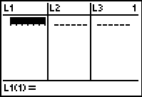
3. Enter data into the Lists. Press enter after each number.  L1= X Values L2= Y Values  *Make sure to check all of your numbers! | 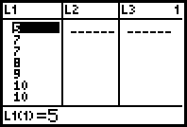
4. To get back to the home screen press the 2ND button and then the MODE button
TURNING ON PLOT
(to see the points on the graph)
5. Now you must turn on Plot so that you can see the points on your graph. Press the 2nd button and then the Y= button. Your screen should look like this. | 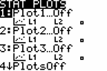
6. Press ENTER to select Plot1. Your screen should look like this. Now move your cursor over the On button and press ENTER. | 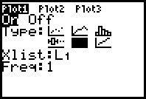
7. Now you must Zoom in so that you can see the points. Press the ZOOM button. Your screen should look like this.
ZOOM IN ON YOUR STAT PLOT
8. Arrow down to the number 9:ZoomStat and press ENTER. You should now see your points on the graph. | 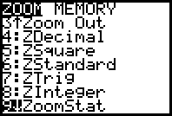
9. To get back to the home screen press the 2ND button and then the MODE button.
FINDING EQUATION LINE OF BEST FIT
10. Press the STAT button. Your screen should look like this. | 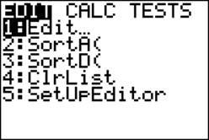
11. Using the arrow key move over to CALC and press ENTER. Your screen should look like this. | 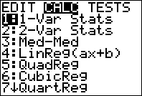
12. Arrow down to 4:LinReg (ax+b) and press ENTER. | 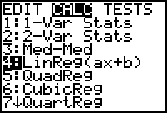
13. Arrow down to Store Reg EQ. Your cursor should be blinking next to it. Your screen should look like this. | 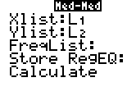
14. Press the VARS button. Then arrow over to the Y-VARS and highlight 1: Function and press ENTER. | 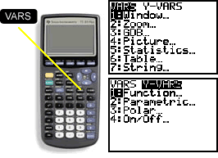
15. Press ENTER to select Y1. Your screen should now look like this. | 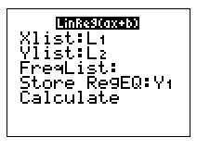
16. Arrow down to CALCULATE and press ENTER. Your screen should look like this.
*You will have different numbers!

A=Slope B= Y-Intercept
17. Press the GRAPH button. Your screen should now have a line of best fit through your plotted points. | 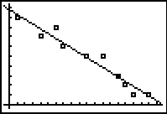
18. To get back to the home screen press the 2ND button and then the MODE button.

TO ROUND VALUES
(to the nearest hundredth)
19. Press the MODE button. Your screen should look like this. | 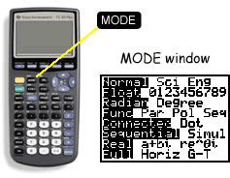
20. Arrow down to the word FLOAT and then arrow over to the number 2.
21. To get back to the home screen press the 2ND button and then the MODE button.
TO TURN ON R (Correlation Coefficient)
22. Press the 2nd button and then the number 0 to get to the Catalog. | 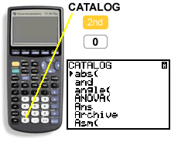
23. Arrow down to DiagnosticOn and then press ENTER. And then press ENTER one more time. Your screen should look like this. | 