Algebra 1 Name ___________________________

Chapter 1 Closure Date ____________________________

1. Use the Order of Operations to simplify the following expressions.

1. $5-2 ∙ 3^{2}$ b. ${(-2)}^{2}$

c. $18 ÷3 ∙6$ d. ${-2}^{2}$

e. $(5-3)(5+3)$

f. $24 ∙ \frac{1}{4} ÷ -2$

g. Why are your answers for parts (b) and (d) different?

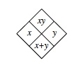

2. Complete the diamond problems using the pattern to the right.

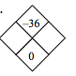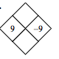



a. b.

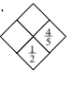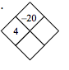

c. d.

3. Complete the table, graph and fully describe the function $y=2\sqrt{x-1}+3$

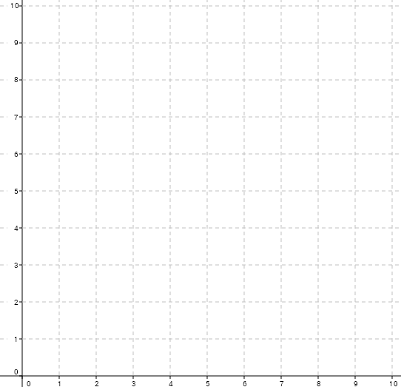

|  |  |
| --- | --- |
| X | Y |
| 0 |  |
| 1 |  |
| 2 |  |
| 3 |  |
| 4 |  |
| 5 |  |
| 6 |  |

4. Solve each equation. Make sure you check your solution.

a. b.

c. d.

5. Find for each function below.

a. b.

c.

6. Evaluate each expression.

a. b. 11|-6|+15 c.

d. e. f.

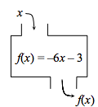

7. Use the function machine shown at right to answer the

following questions.

1. If the input is -8, what is the output?
2. If the output was 21, what was the input?