Algebra 1 Name ____________________
Chapter 2 Closure Date _____________________

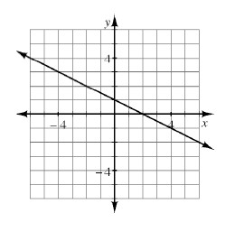
1. For the line graphed at right:
  - Find the slope.
  - Find the y-intercept.
  - Write the equation.

2. Find m and b in the following equations. What do m and b represent?
a. y = 2x + 1 b. $y=\frac{2}{5}x-4$

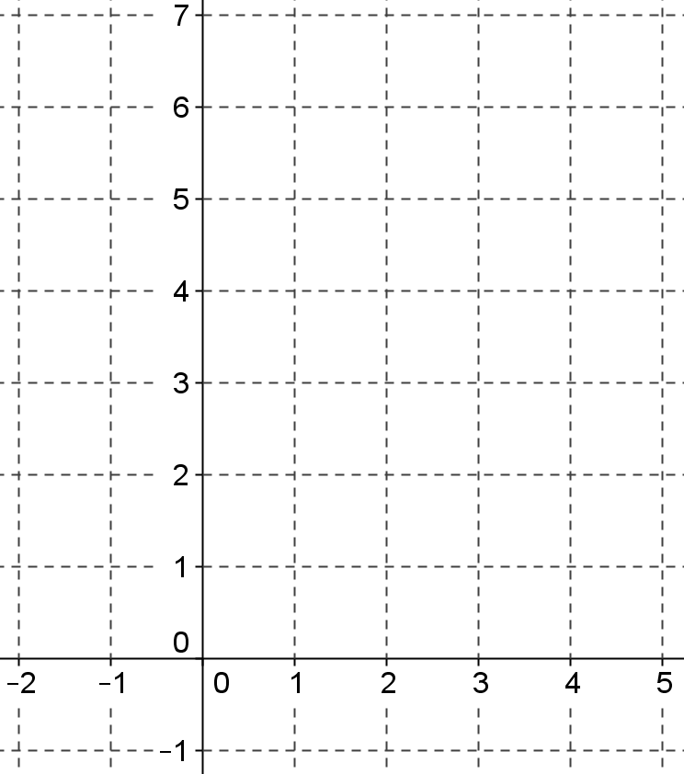
3. Graph each equation from problem #2
a. b. b.

4. Shirley starts with $85 in the bank and saves $15 every 2 months. Write an equation for the balance of Shirley’s bank account.

5. Find the equation for each linear relation described in the tables below.
a.
x | -2 | -1 | 0 | 1 | 2
y | 19 | 14 | 9 | 4 | -1

b.
x | 2 | 3 | 4 | 5 | 6
y | 22 | 31 | 40 | 49 | 58

6. Write a rule for the given tile pattern. How many tiles will be in figure 58?
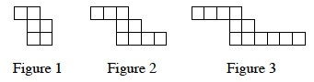

7. Solve for w: 6w − 5 + 8w − 2w − 3 = 9w − 24

8. Copy and complete the table below for the rule y = x² − 6x + 5. Then graph the rule.
x | -1 | 0 | 1 | 2 | 3 | 4 | 5 | 6 | 7
y
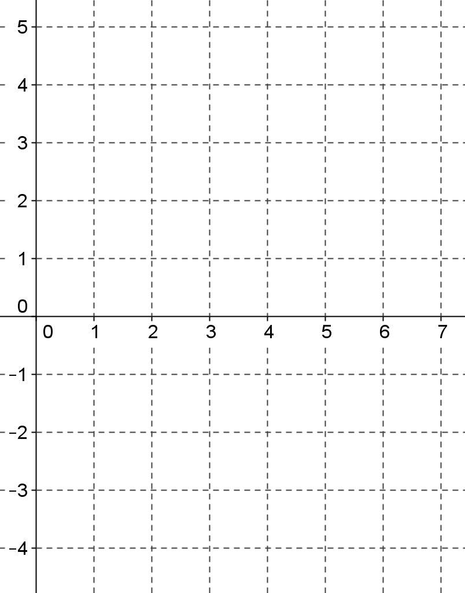
a. Completely describe your graph using the graph investigation questions from your math notes booklet.
______________________________________
______________________________________
______________________________________
______________________________________
______________________________________
______________________________________
______________________________________

b. Is the relation a function?

c. State the domain and range.

9. Write the equation of the line that passes through the point (-5, 7) with slope of 2.

10. Find the equation of the line that passes through the points (−5, 7) and (10, 1).

11. Evaluate the expressions below for the given values.
  - −3x² + 4x + 5 for x = −2 b. 6− (5x − 9)² for x = 1

c. $\frac{-4}{k+7}$ for k = −8 d. $\frac{2m}{n-1}-m^{3}-n$ for m = −2, n = 3

e. If $f\left(x\right)=\frac{-3}{x+6}$ , what value of x would be excluded from the domain? How do you know?

12. Complete each diamond problem.
$$\frac{3}{7}$$
3
$$\frac{3}{4}$$
$$\frac{1}{8}$$
$$\frac{2}{3}$$
$$\frac{1}{6}$$
a. b. c.

13. Check your answers on the algebra website: wnalgebra.weebly.com. Which problems do you feel confident about? Which problems were hard? Make sure you talk with your teacher about the problems you need help with or go to math help before the Individual Test.

