Algebra 1 Ch. 6 TI-Nspire Instructions
Adding Points in a List
1. Click “ON” and create a new document.

2. Click “Add List & Spreadsheets” | 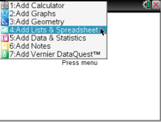
3. Move the up arrow to be in the top left corner of the table.

4. Title the first column with what represents x (for example: time) | 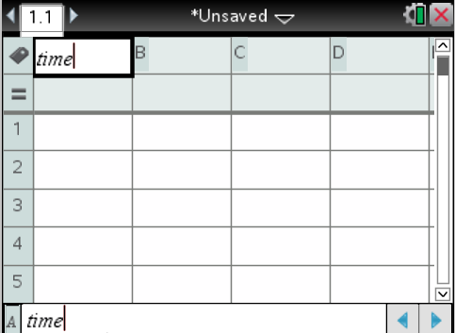
5. Enter your x values in the x column | 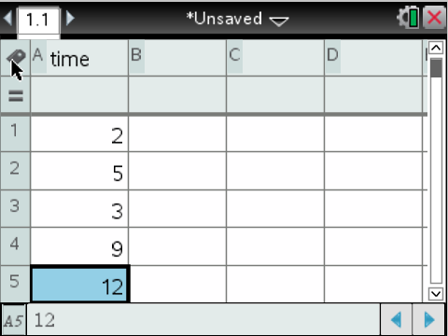
6. Click “tab” to move to the right. Title the second column with what represents y (for example: distance) | 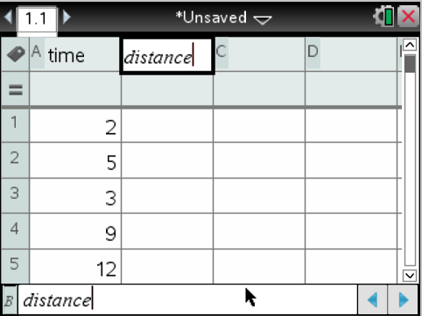
7. Enter your y values in the y column | 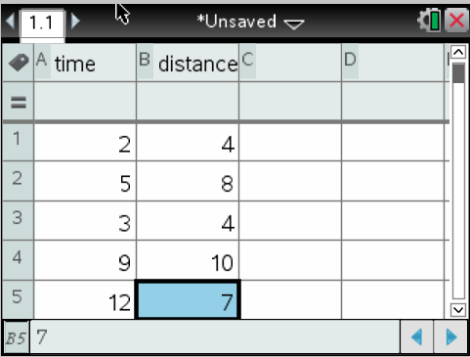
Making a Scatter Plot Graph
8. Click “ctrl” then “doc” to insert a new page.

9. Click “Add Data & Statistics” | 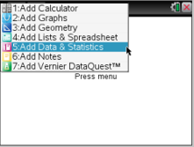
10. You should now get a page that looks like one to the right. | 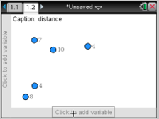
11. Click on the bottom axes “click to add variable”. Select the variable you chose for the x axes (in this example, time). | 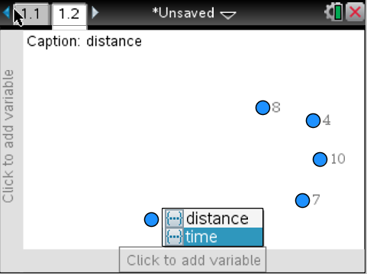
12. Click the y axes where it says “click to add variable”. Select the variable you chose for the y axes (in this example, distance). | 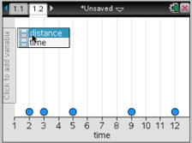
13. You should now have a scatter plot with your axes labeled. | 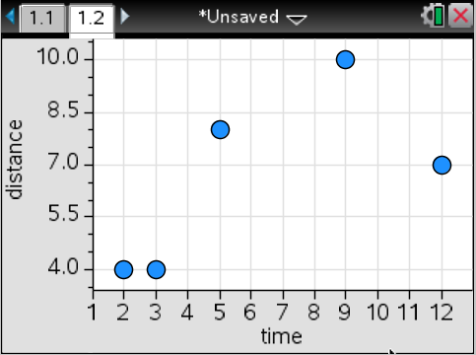
To Find the Equation of Best Fit (LSRL)
14. Go back to your list on the previous tab by clicking “ctrl” then left arrow on the touch pad.
15. Move to the third column and click “menu” | 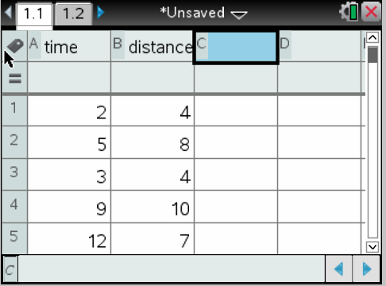
16. Select “Statistics” then “Stat Calculations”. | 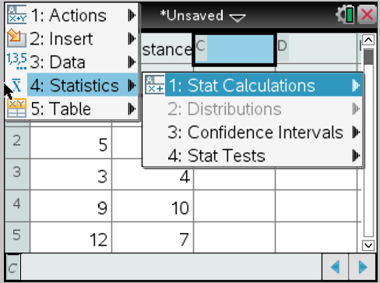
17. Select “Linear Regression (mx+b)”. | 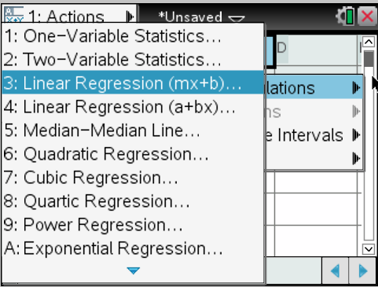
18. Now select the variables you used for your x and y lists using the drop down menu from the arrows at the right of each space. In our example, x was time and y was distance. Click “OK”. | 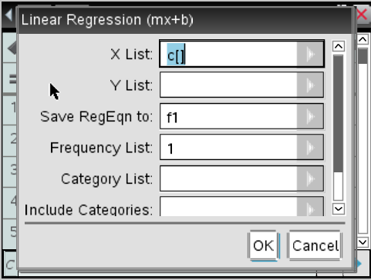
19. In your table you should now see more data about the line of best fit (LSRL). Across from m is your slope and across from b is the y-intercept. | 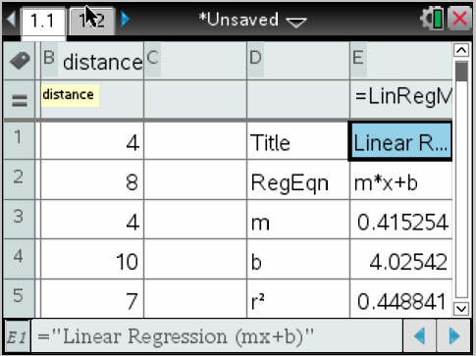
20. Scroll down to see the r², r and residual values. | 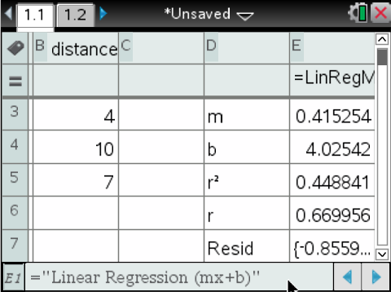
To Graph the Line of Best Fit (LSRL)
21. From your scatter plot graph page, Select “menu” and “Analyze” | 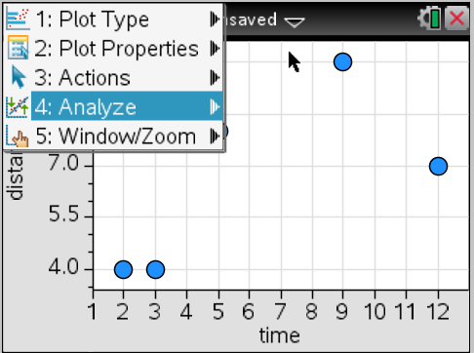
22. Then select “Regression” and “Show Linear (mx+b)” | 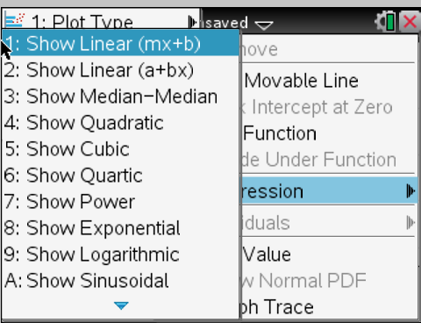
23. You should now see your scatter plot with the line of best fit drawn in and the equation. | 